As we build our new school, we are always on the lookout for resources to fund important programs, purchase supplies and help fund school improvements. We want to take full advantage of the many funding opportunities available to us. One easy way is through royalty programs where our school can receive money back on purchases you make every day.

Visit http://www.theglobeacademy.org/royalty-programs/ to access these programs below and look for updates. Thank you!

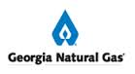 | ENROLL YOUR GEORGIA NATURAL GAS ACCOUNT, AND WE EARN MONEY  Go to http://www.trueblueschools.com and enroll. Through the True Blue Schools program, GNG donates $5 every month you remain a customer, up to $60 per year.
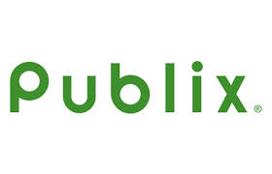 | SWIPE THAT CARD!  Every time you swipe your card at Publix, no matter what you buy, Publix gives back to our school. Pick up one of the Publix Partners keychain cards in the school’s front office. Have the cashier scan it each time you shop at Publix. Publix will donate a portion of what you spend to GLOBE.
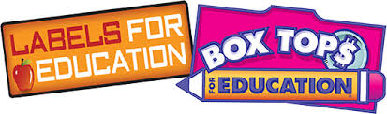 | KEEP CUTTING AND SAVING!  Looks for Labels for Education and Box Tops on many of the things you already buy. We can earn the money back that is listed on the label. Cut them out and save them – we do collections throughout the year. For a list of products visit: http://www.labelsforeducation.com/ and http://www.boxtops4education.com/.
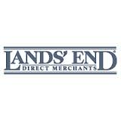 | WANT TO CONTRIBUTE TO THE SCHOOL WHEN YOU BUY UNIFORMS?  With the Lands' End School Rewards program our school can receive up to a 3% cash-back reward from our school's total uniform purchases. The customized website for The Globe Academy is live and may be accessed here:  http://www.landsend.com/pp/SchoolSearch.html?action=landing&selectedSchoolNum=900160615. Our preferred school number is: 900160615.
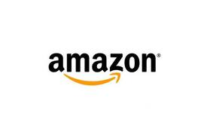 | DO YOU SHOP AT AMAZON.COM?  Then access Amazon.com from THE GLOBE website and Amazon will donate up to 8.5% of your total purchases to THE GLOBE. The percentage varies based on volume. The more transactions the higher the percentage so use THE GLOBE website link every time!
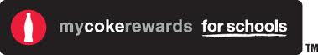 | SAVE YOUR COKE PRODUCT CODES  You can donate points to our school, so we can get rewards like art supplies and sports equipment, and support all the ways kids play. Go to mycokerewards.com/schools and start donating today!
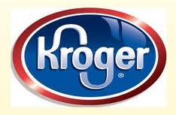 | Kroger’s Community Rewards program!  Visit krogercommunityrewards.com to simply connect your Kroger Plus card to The GLOBE. Every time you scan your rewards card at the checkout counter, Kroger will give back to our school – it’s that simple! The GLOBE Academy’s organization number is 23254.
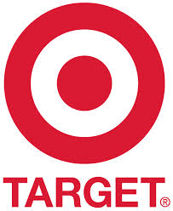 | DO YOU HAVE A TARGET REDcard?  If so, you can sign up for Take Charge of Education and designate our school. For cardholders enrolled in the program, Target donates 1% of all purchases made at a Target store or at Target.com. Target also donates 0.5% of all Target Visa Credit Card purchases made outside of Target. For more information on this program visit:  https://www-secure.target.com/redcard/tcoe/home.
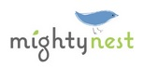 | Visit Mightynest.com to shop for natural, organic and non-toxic products all in one place. All of the products they sell are free from known toxic ingredients such as: BPA, PVC, Phthalates, Lead, Melamine, Formaldehyde, Flame retardants, Parabens and more. Use this link http://schools.mightynest.com/schools/ga/atlanta/the-globe-academy to earn money for our school.
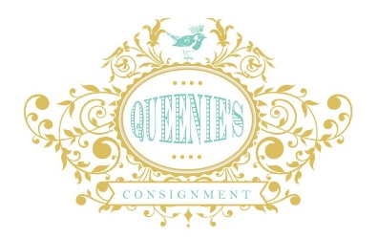 | Queenie’s Consignment (Oak Grove shopping center)  Getting organized and cleaning out your house can now help GLOBE earn money. The GLOBE Academy Foundation has an account at Queenie’s Consignment shop in the Oak Grove shopping center at 2755 Lavista Rd. They specialize in high end women's clothing, accessories and jewelry as well as home furnishings.
Consign Kidz (Toco Hills)
Cleaning out last season’s kids clothes can also help GLOBE earn money by consigning the items under the GLOBE Academy Foundation account. The store takes seasonal kids clothing, accessories, toys, books and women’s and maternity clothes as well.

